UAT Deployment

Step 1:
- UAT Deployment is to be done before going for new QA Build through Jenkins.
- Login to Jenkins: http://10.101.120.179:8049/
- Give the Credentials (Username and Password)
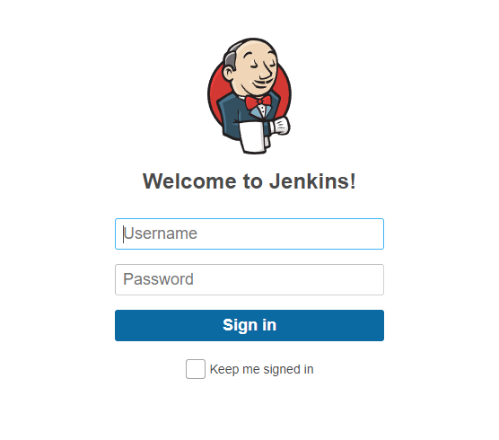
Step 2:
- Select VBC_UAT_186

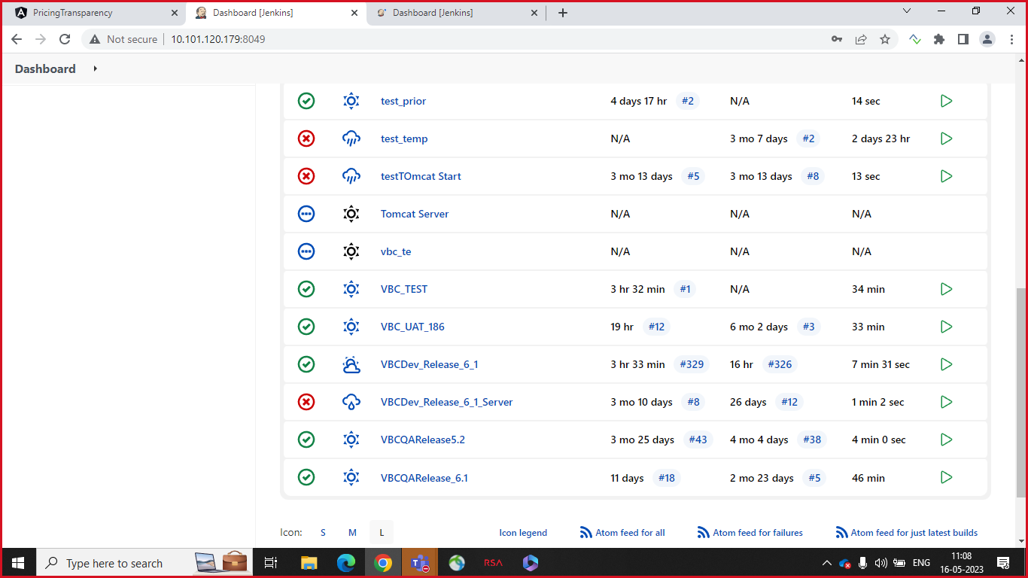
- Click on Build Now to create a new Build
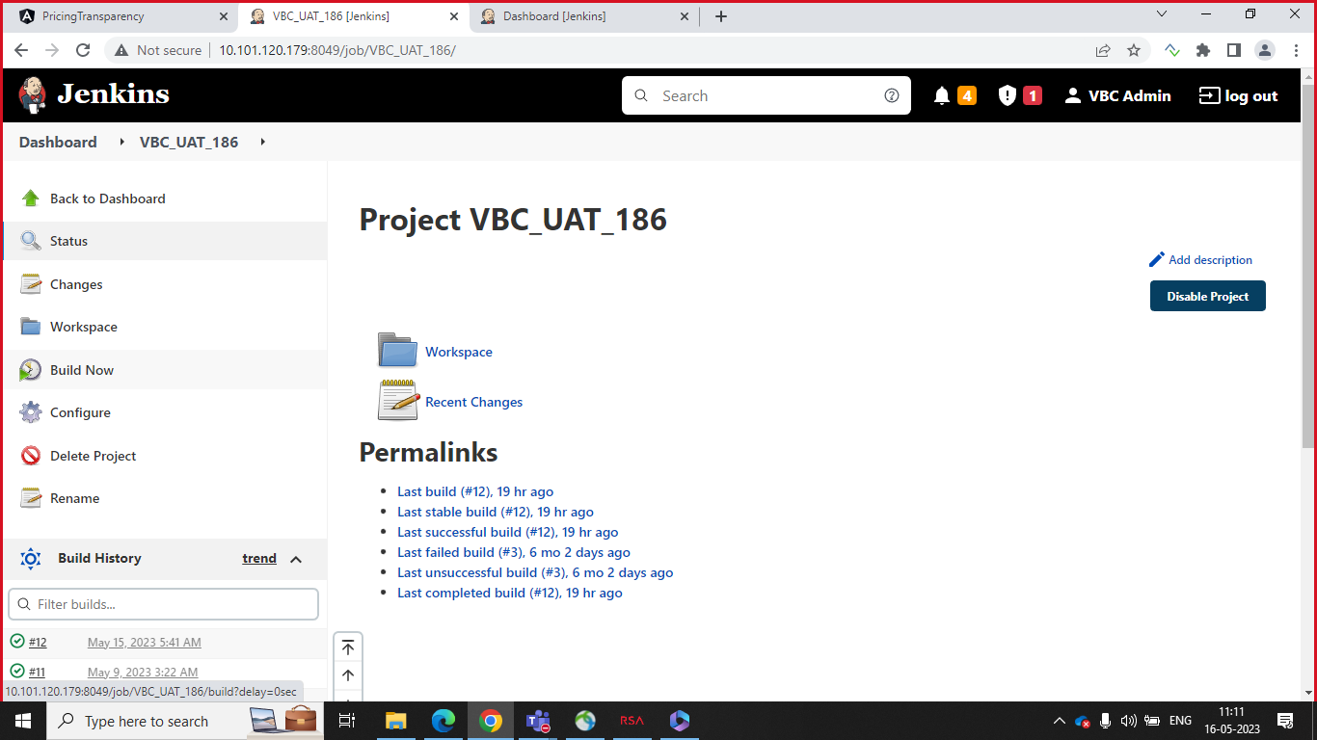

- Now you can see Build process and it will take some time to finish the Build.
- You can also see the console output in the Dashboard.
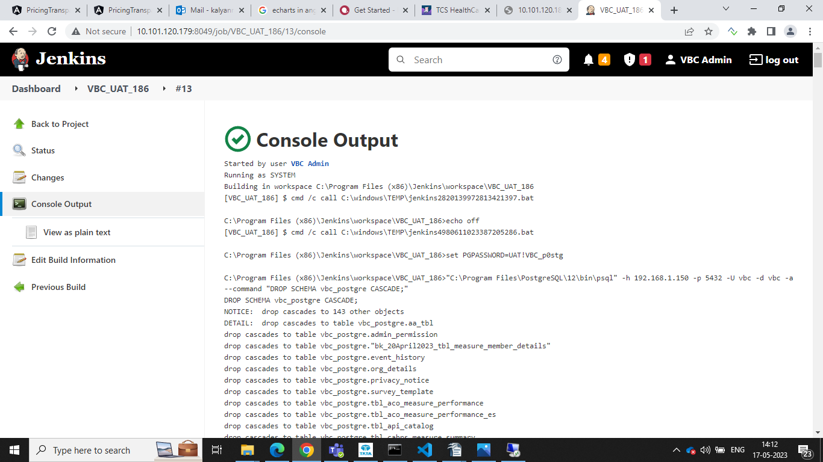
Step 3:
- Connect to RDP: 10.101.120.186
- Provide the required credentials to login RDP. (Username and Password, Password is Indian domain Password)
- Now navigate to path: D:\R6UAT
- In this path, you can see script files for Shutdown and uat_bulid.
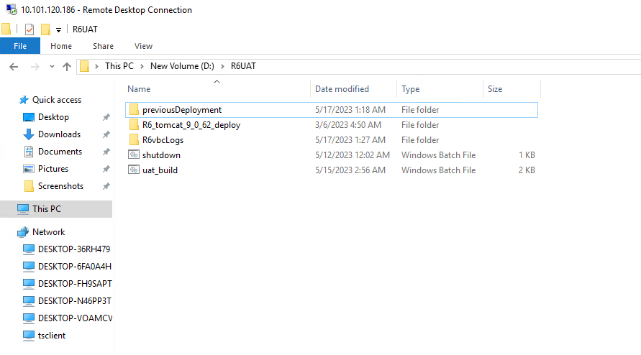
- Script file for Shutdown:
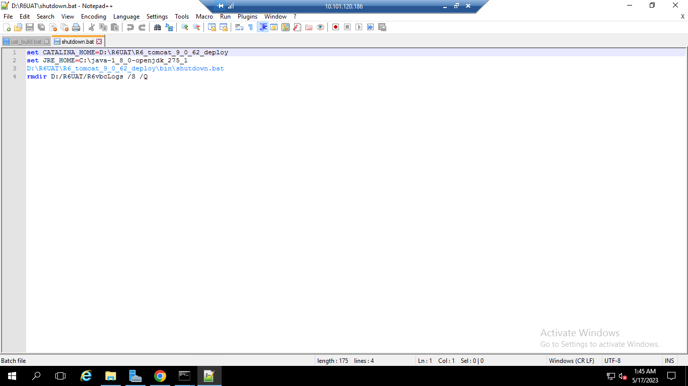
- Script file for uat_build:
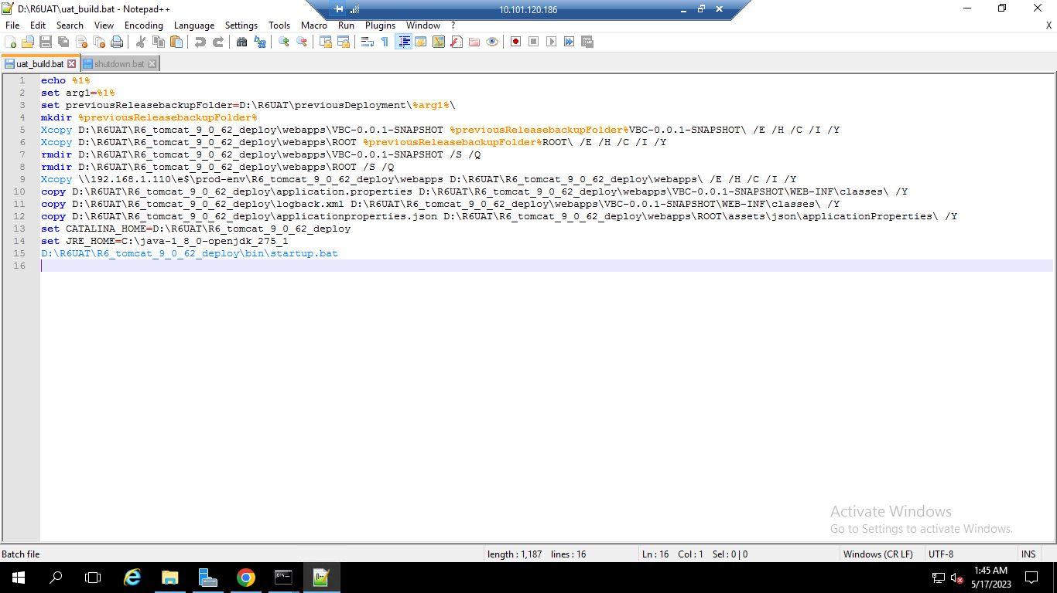

Step 4:
- Open the command Prompt in this path.
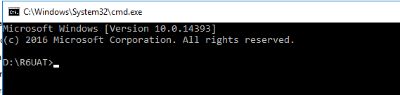

- Provide shutdown.bat command in the command prompt
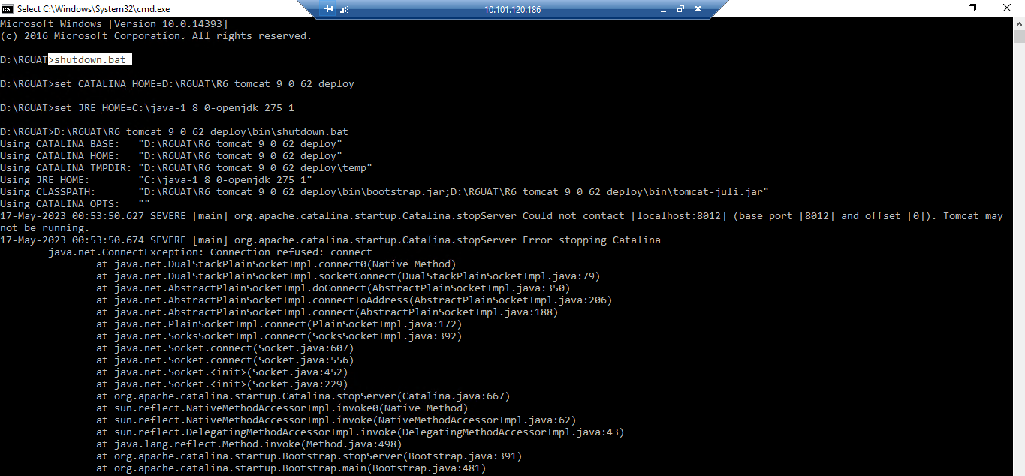

- Provide uat_build.bat May17_2023 command in the command prompt.
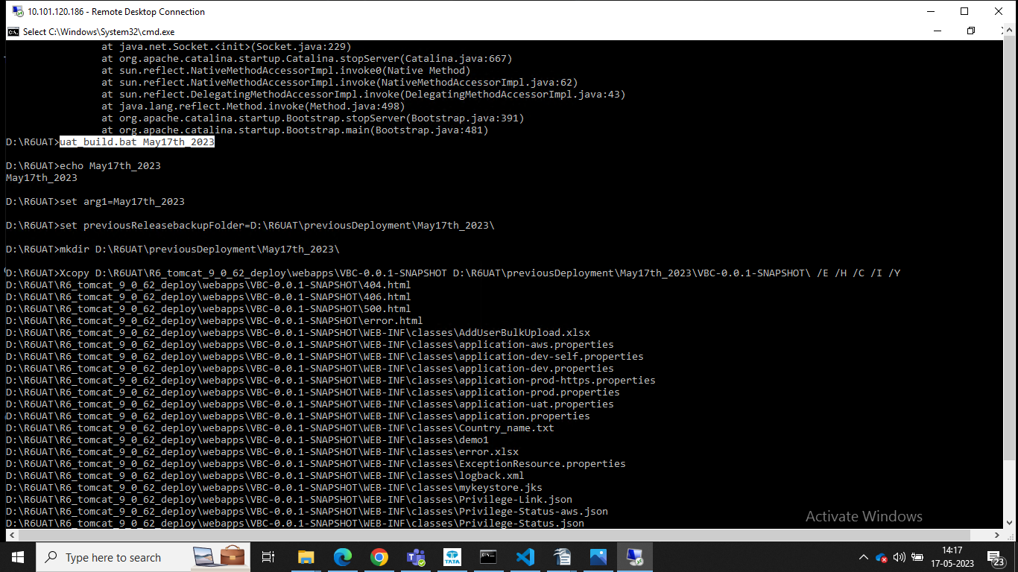

- You can also view May17_2023 file in previousdeployment folder.
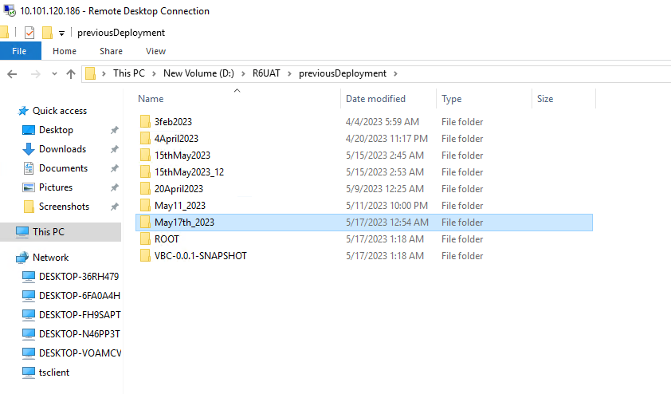
- Check for any exceptions we are getting in the command prompt. If not UAT Build is successful.
- Go to Step 2 and See Jenkins Build is successful.
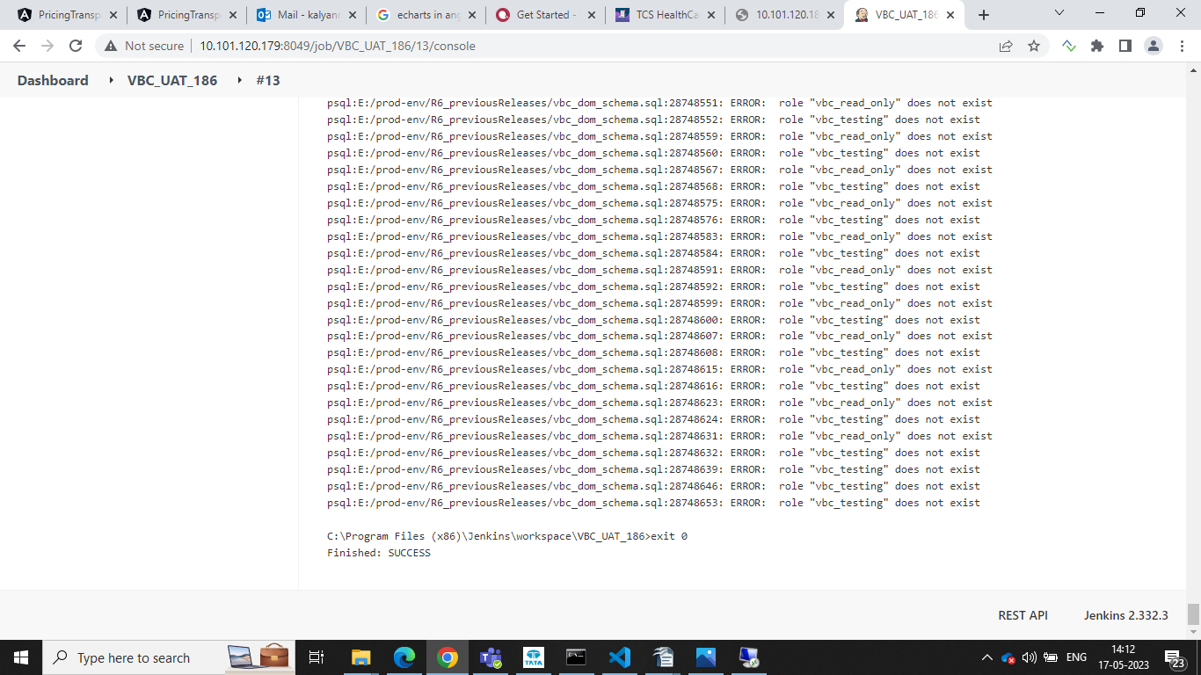

If you are getting any access denied errors in command prompt while running uat_build.bat May11_2023, then we need to follow the process.
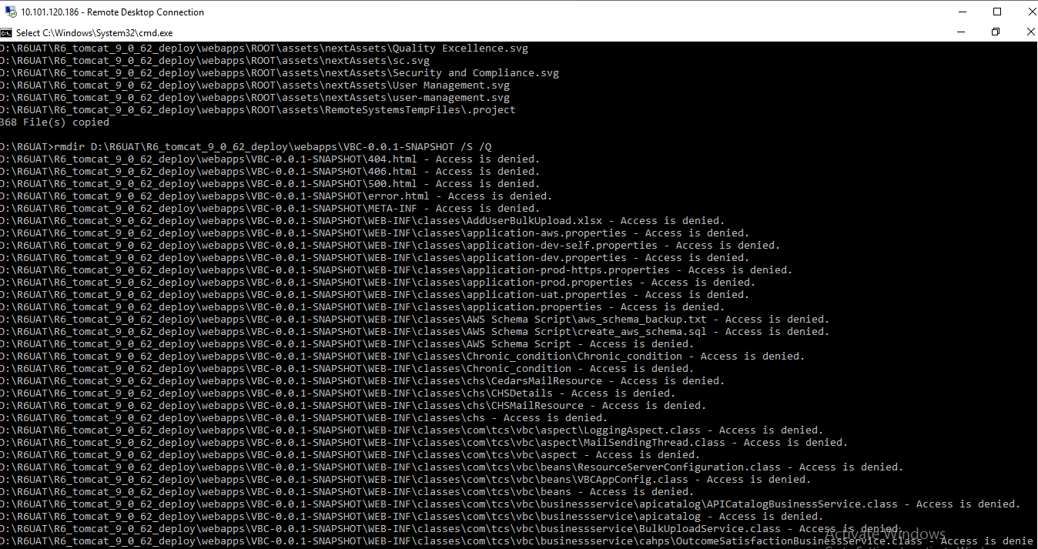
- Delete the R6VbcLogs folder in D:\R6UAT path and delete the existing files in the path: D:\R6UAT\R6_tomcat_9_0_62_deploy\webapps
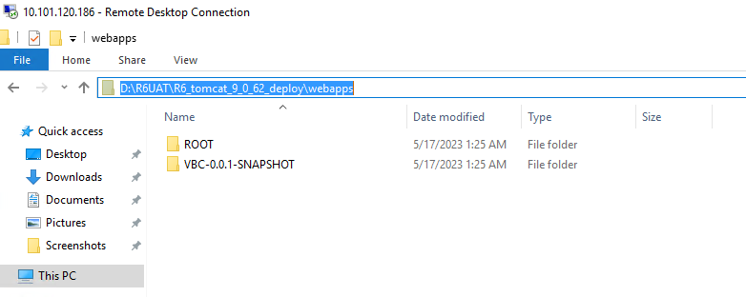
- Also delete the logs folder in D:\R6UAT\R6_tomcat_9_0_62_deploy\logs folder before giving shutdown.bat or startup.bat commands
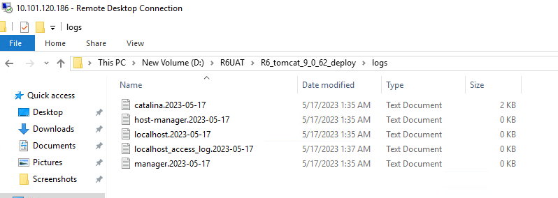

- Open the uat_build folder with notepad++
- As we can see, line number 9, go to the first path mentioned and the path is \\192.168.1.110\e$\prodenv\R6_tomcat_9_0_62_deploy\webapps
- Navigate to this path and copy the webapps files and paste the copied files in D:\R6UAT\R6_tomcat_9_0_62_deploy\webapps path.
- Copy commands from uat_build Script file from line number 10 to 15 and execute it in the command prompt and check for any exceptions occurring. If no exceptions occurred, then UAT Build is successful.

